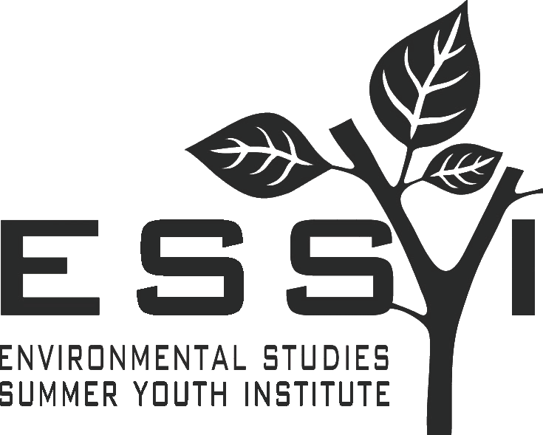Application

ENVIRONMENTAL STUDIES SUMMER YOUTH INSTITUTE
Education Department
Hobart and William Smith Colleges
300 Pulteney St., Geneva, New York 14456-3397
Telephone: (315) 781-4401/ Fax: (315) 781-3843
E-mail: essyi@hws.edu • Website: essyi.hws.edu

BIOGRAPHICAL INFORMATION
Legal Name Prefer to be called
first middle initial last
Address
number and street apt. city/town state zip code
Telephone ( ) Age _______ Date of Birth ___/___/____Social Security No.
E-mail
Gender (circle): Male Female Transgender Prefer not to disclose
Other/Self Identify:
FAMILY
Mother (or Guardian) Father (or Guardian)
Home Address Home Address
Occupation Occupation
Contact Telephone/Email Contact Telephone/Email
Have any of your relatives or close friends attended ESSYI or Hobart and William Smith Colleges? If so, please include their names, class years, and relationship to you.

EDUCATION
Current High School Expected Completion (mo./yr.)

High School Address

Name of teacher writing recommendation Telephone ( )

Dates of attendance of your current high school:

Have you attended any other high school or academic summer program? YES NO

If YES (list where and dates attended) __________________________________________________________

________________________________________________________________________________________

Have you previously attended HWS? YES NO If YES (when?)

Country of citizenship (if not USA) __________________________________________________________

Ethnic Origin (optional)
I describe myself as (please check one):

_____ American Indian _____ Caucasian American, White, Anglo (non-Latino)

_____ Latino (including Puerto Rican) _____ Black, African American (non-Latino)

_____ Asian or Pacific Islander _____ Other (please specify) ___________________

FOR OUR INFORMATION
How did you learn about our program? If through a website, please be specific.

INTERESTS AND ACTIVITIES (attach separate sheet if necessary):
Please describe your current academic interests:

Briefly describe your extracurricular activities:

(Please complete the other side of this form.)

PERSONAL STATEMENT (attach separate sheet to this form)
It is our aim to know you as well as possible through this application. Please take this opportunity to tell us something about yourself that will give us clearer insight into who you are and how you think. You may choose to describe why you are interested in attending this program, discuss an environmental topic of interest to you, or find another way to help us know you better. The topic and approach are entirely up to you.

MAKE SURE EACH OF THESE BOXES IS CHECKED TO COMPLETE THE APPLICATION PROCESS

- RETURN - this APPLICATION FORM and your PERSONAL STATEMENT.

- REQUEST - TEACHER RECOMMENDATION FORM - He/she can email it or send it to us.

- REQUEST - YOUR SCHOOL TRANSCRIPT - Request that a copy be sent directly to us (including fall grades, and, if available, PSAT, SAT or ACT scores).

Application materials, recommendation forms and transcripts should be mailed or faxed to: Jim MaKinster, Director, ESSYI, Merritt Hall, Hobart and William Smith Colleges, 300 Pulteney Street, Geneva, NY 14456-3397; Fax 315-781-3843.

Upon acceptance into the program, you will be mailed a registration form that must be completed and returned with a $500 deposit. This non-refundable deposit guarantees you a place in the Institute.

Students admitted to Hobart and William Smith Colleges on a non-matriculating or “visiting” basis are not actively working towards completion of an undergraduate degree or enrolled in a degree program at HWS. As an ESSYI participant you will be considered a Non-Matriculated Student. You will receive academic credit upon successful completion of the Program.

The Environmental Studies Summer Youth Institute reserves the right to make any adjustments to the curriculum it deems necessary.

Student Signature Date ____________________

Parent/Guardian Signature Date ____________________

